

Dynamics 365  
Technology Specialist Environment



Analytics & Reporting   
Demo Setup – Excel Data

Authored by:

**Scott Sewell**

Principal Program Manager

Fabric CAT (Customer Advisory Team)

Version 3.2

Contents

Introduction 2

Getting your Dataverse environment ready 3

*Ensure the Power BI Extensions are updated* 3

*Ensure the option to allow Embedded Power BI content is enabled* 3

Create Local Copies of the Solution and Source Data Excel File 3

Create a OneDrive ‘Shared Library’ 5

Setup Workspace in Power BI Online 6

Download the Power BI dashboard and connect to your data source 8

Embed Power BI Dashboard in D365 Dashboard list. 12

Enable the New Power BI Report and Publish all Changes 13

Hints 15

# Introduction

These assets are designed to help demonstrate the power of using Power BI analytics and reporting to expose the value of the data in a Dynamics 365 CE implementation. The sample data is sourced from Excel (originally exported from Dynamics) as a way of making them easy to transport from one demo environment to another and to allow for customization for different demo scenarios.

# Getting your Dataverse environment ready

## *Ensure the option to allow Embedded Power BI content is enabled*

In Power Platform Admin Center navigate to “Settings/Product/Features.” Under “Embedded content”, ensure that the “Power BI visualization embedding” option is set to “On.” (Click Save)  
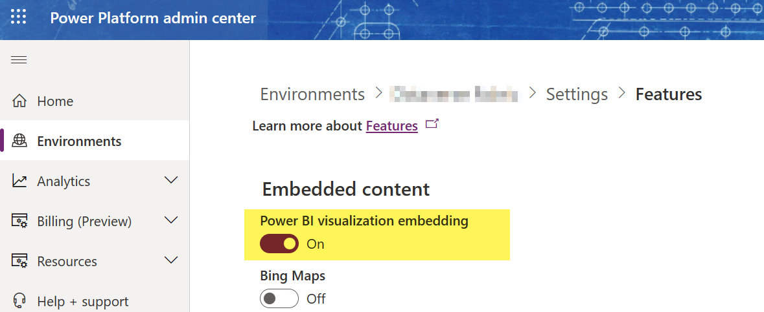

# Create Local Copies of the Solution and Source Data Excel File

1. Download the example files from the source: <https://github.com/mscottsewell/ContosoBI> (From the “Code” menu choose “Download Zip”  
   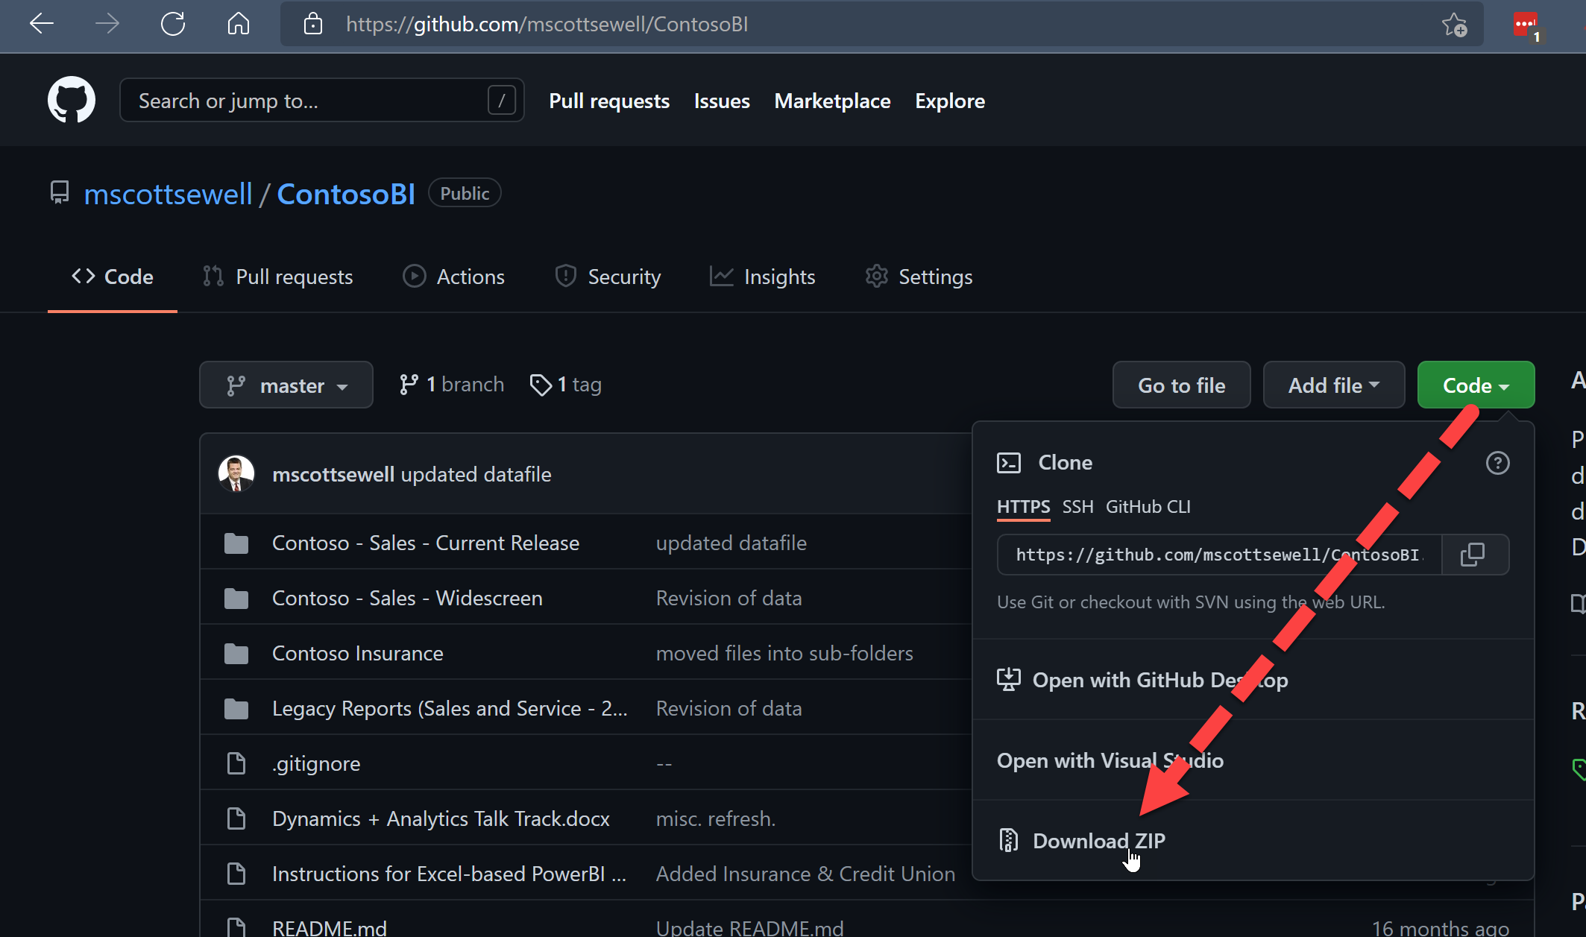
2. Once Downloaded - right click on the file, select ‘Properties’ and then check the ‘unblock’ option and ‘apply’ that change.  
   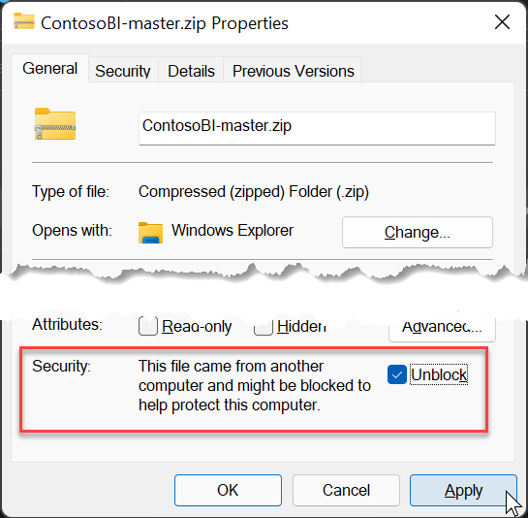
3. Right click on the zip file and “extract” it to a temporary folder on your pc. – We’ll make a few changes before publishing it to your instance.
4. Open “\ContosoBI-master\Contoso - Sales - Current Release\Excel Data”:   
   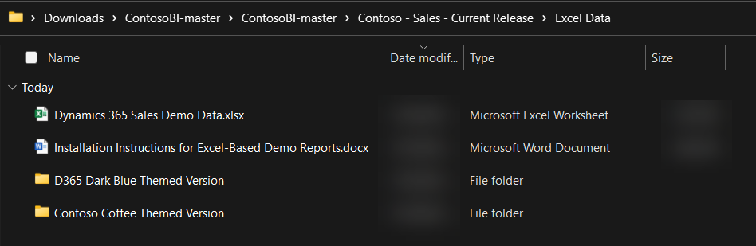

# Create a OneDrive ‘Shared Library’

1. Open OneDrive (logged in with your demo admin credentials)   
   Create a ‘Shared Library’ named “Contoso Analytics”.   
   Add your System Administrator account as a member.  
   Set Privacy to “Public (anyone in the organization)”.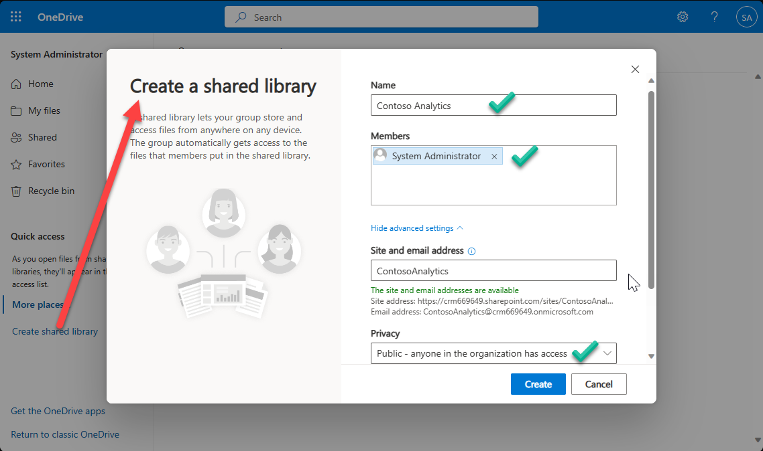
2. Upload the Excel file “Dynamics 365 Sales Demo Data.xlsx” into the new directory.
3. Open the file from One Drive “In App” – (It’s important to open the file *from OneDrive* and not from the copy on your desktop.) – You may be prompted for your demo tenant admin name and password in order to allow Excel to open the file from OneDrive.  
   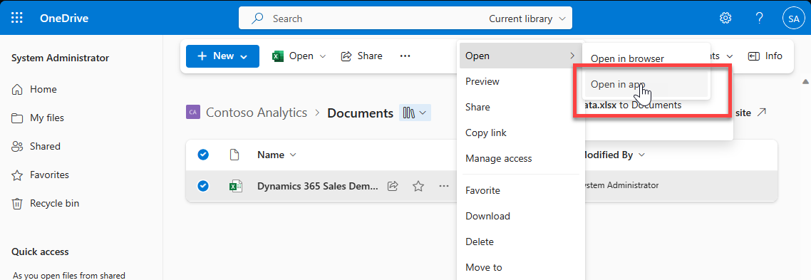
4. With the file open in Excel, click on “File” then “Info” and then “Copy Path” 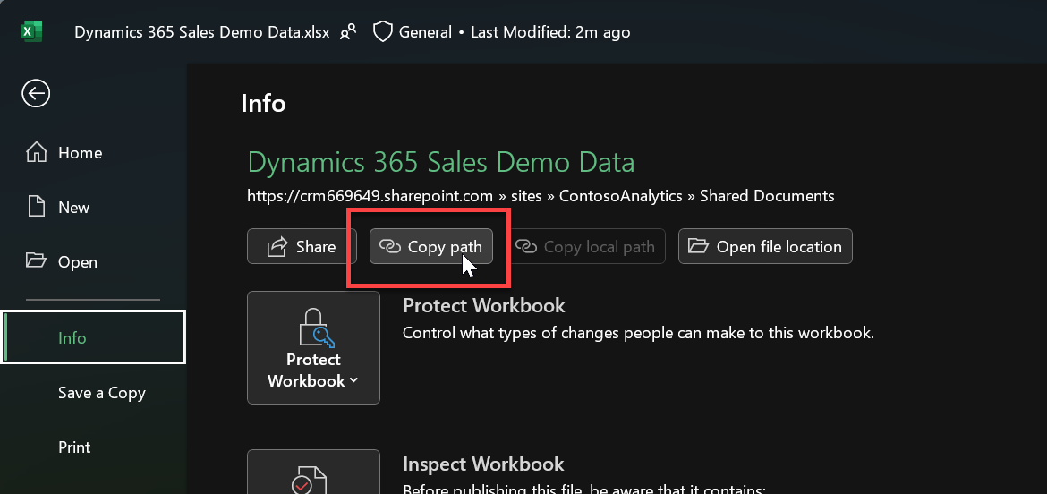

You’ll need this URL in a moment – so just paste it into somewhere handy such as notepad – we’ll use it when importing the solution.

It will look something like:

https://d365demots00000.sharepoint.com/sites/ContosoAnalytics/Shared%20Documents/Dynamics%20365%20Sales%20Source%20Data.xlsx***?web=1***

We’ll need all ***except*** that last **“?web=1”**

https://d365demots00000.sharepoint.com/sites/ContosoAnalytics/Shared%20Documents/Dynamics%20365%20Sales%20Source%20Data.xlsx

# Setup Workspace in Power BI Online

1. Open Power BI Online (Ensure that you are signed in to your Online Demo Instance as an Admin)  
   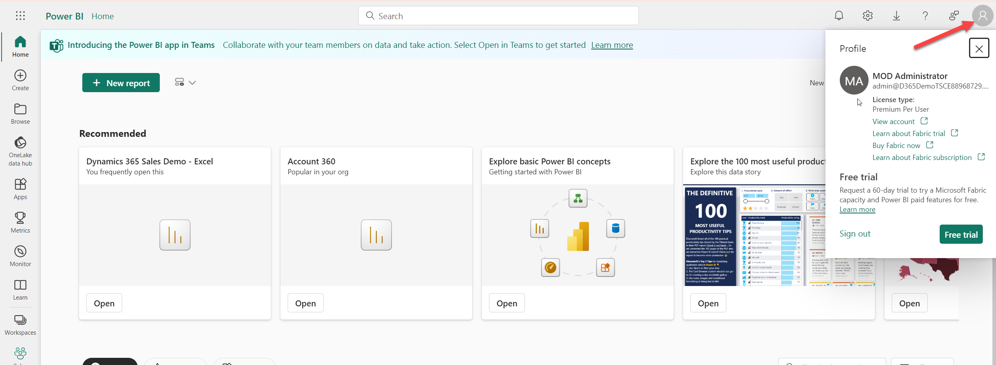
2. Navigate to Workspaces and select New Workspace.   
   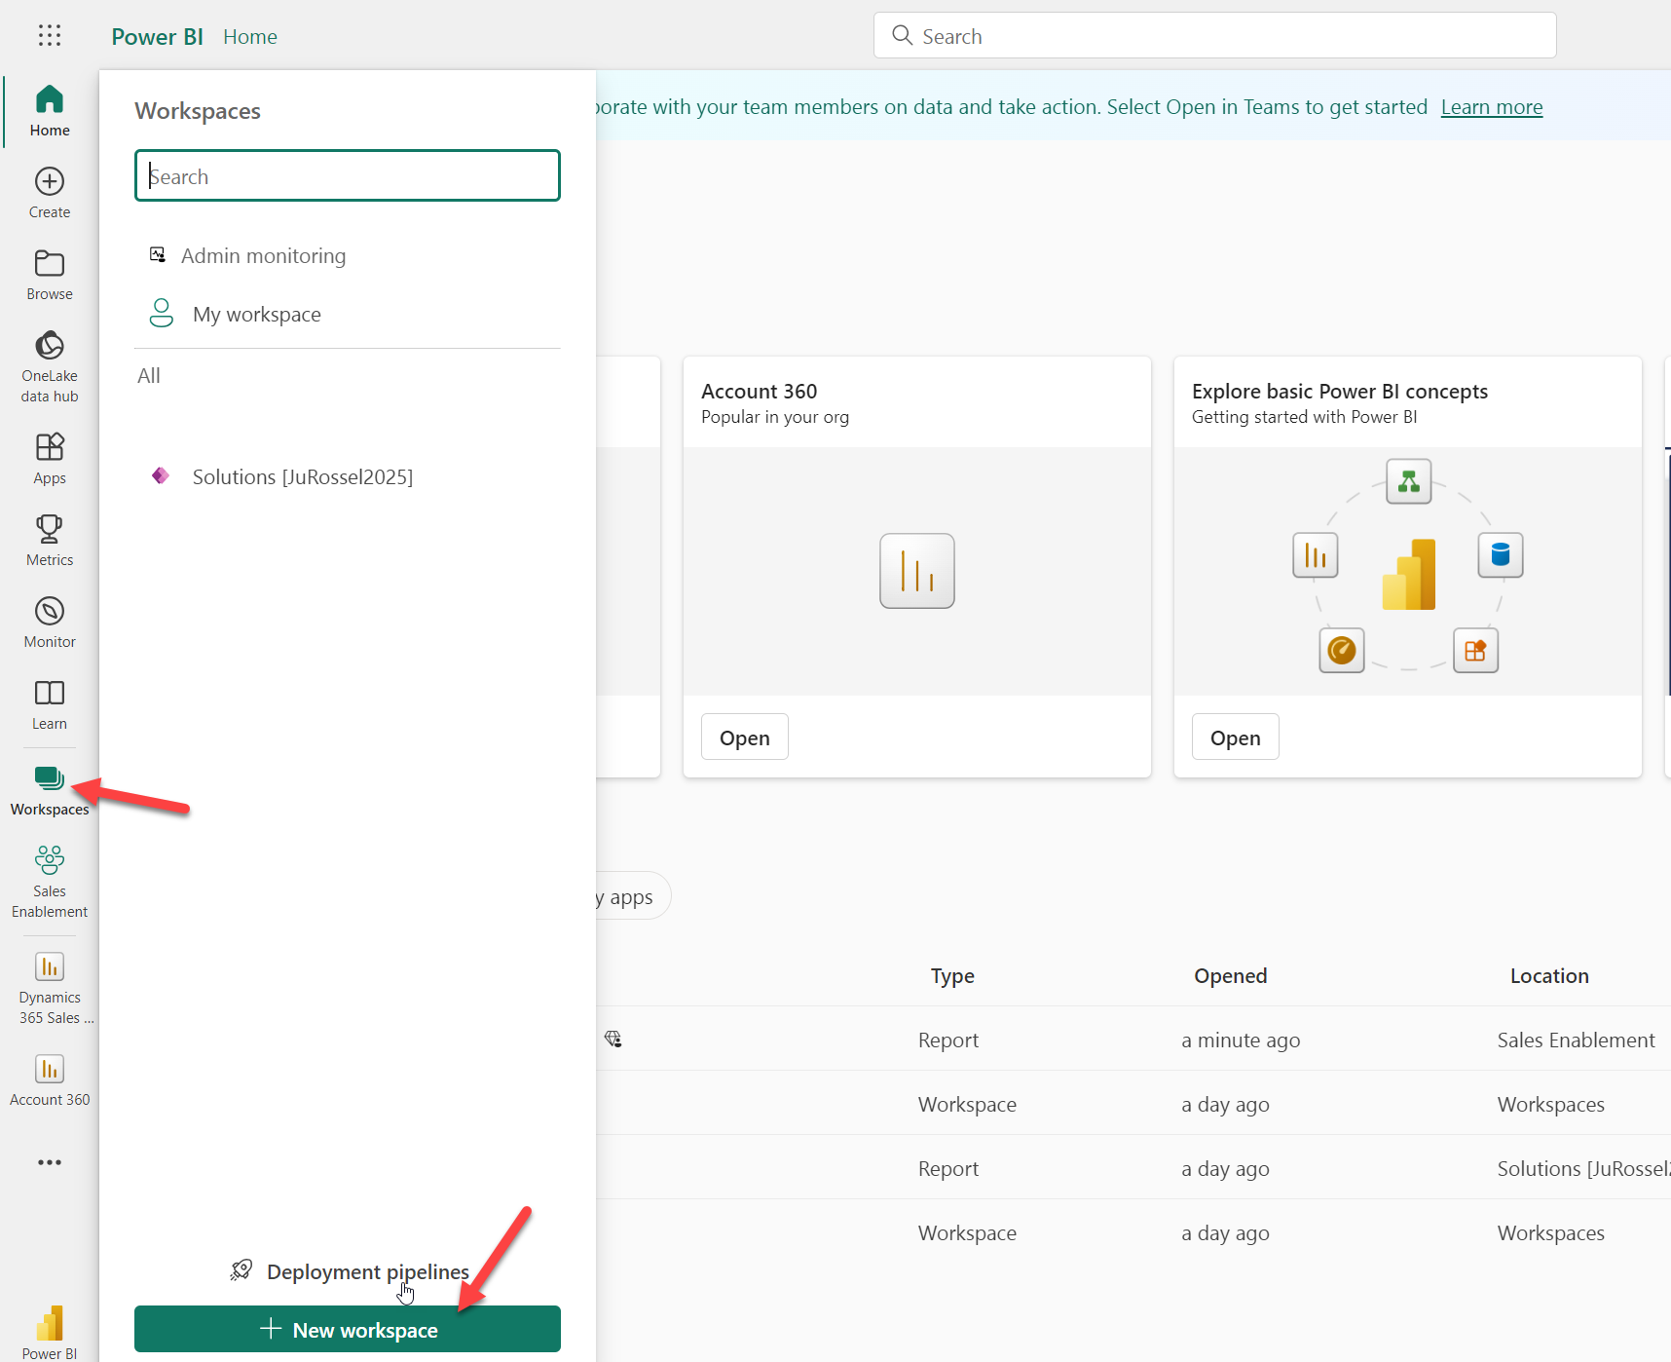
3. Give your new Workspace a name and select Apply   
   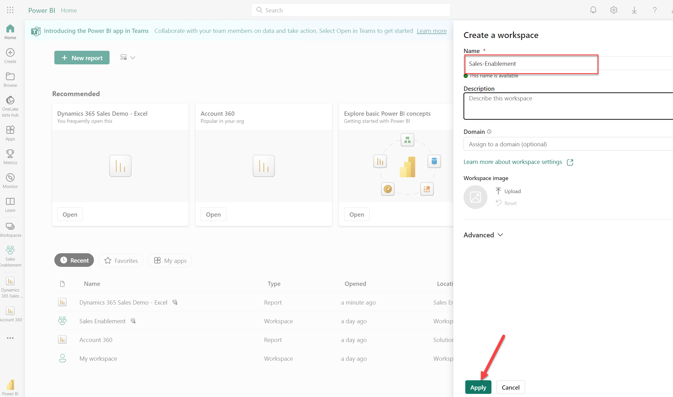

# Download the Power BI dashboard and connect to your data source

1. Copy the Power BI report

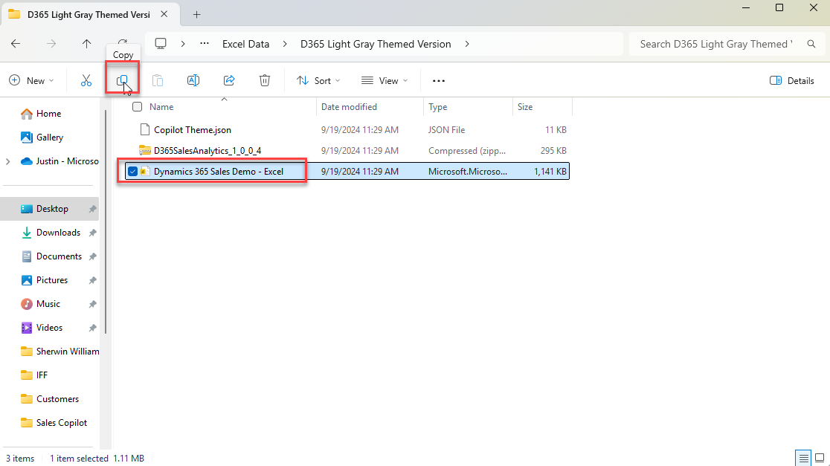

1. Paste the file to a local folder on your machine. 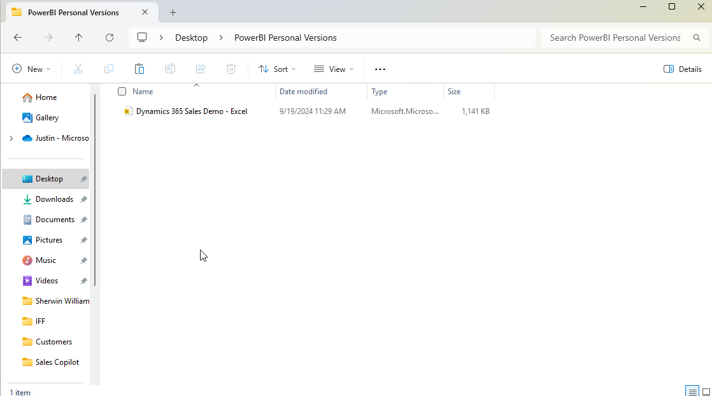
2. Open the file with Power BI Desktop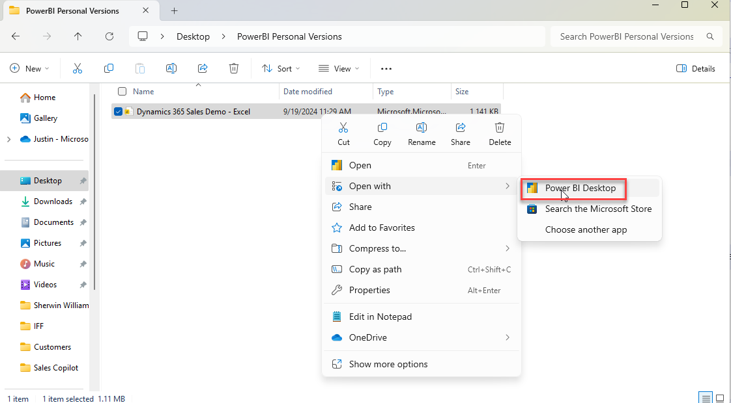
3. If prompted, select “Upgrade Maps”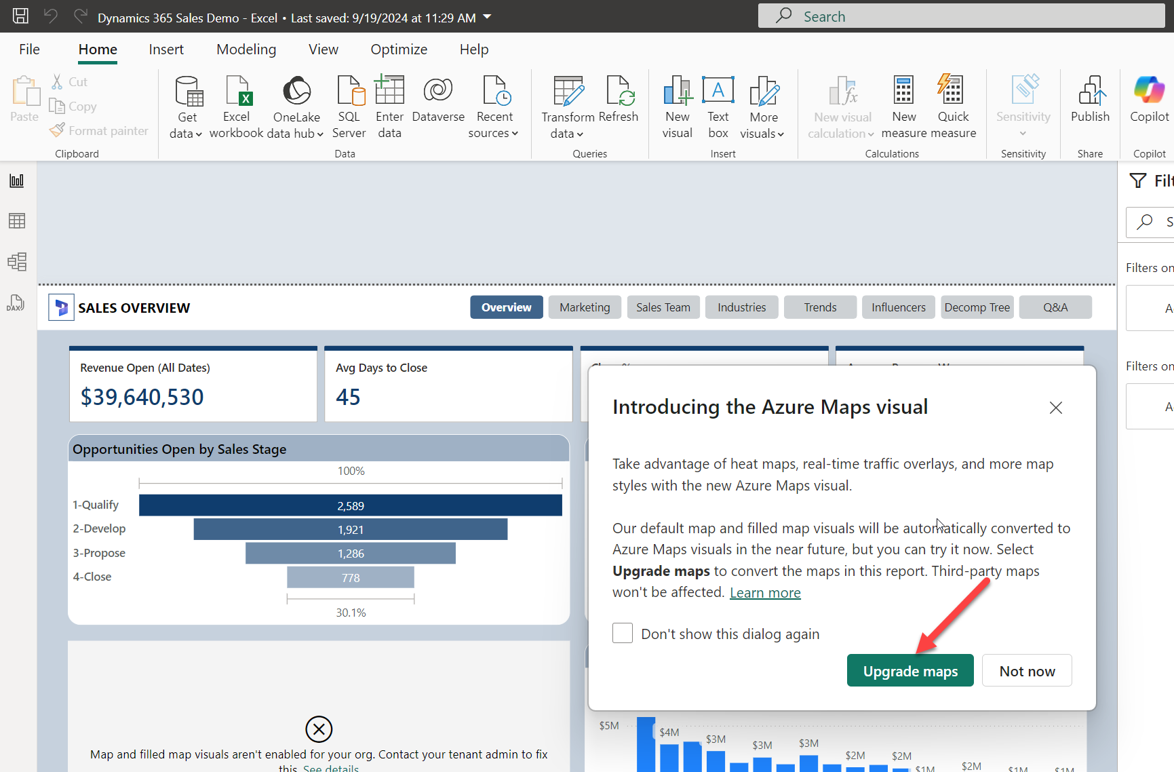
4. Ensure you are logged into your Demo Tennant with your admin credentials.   
   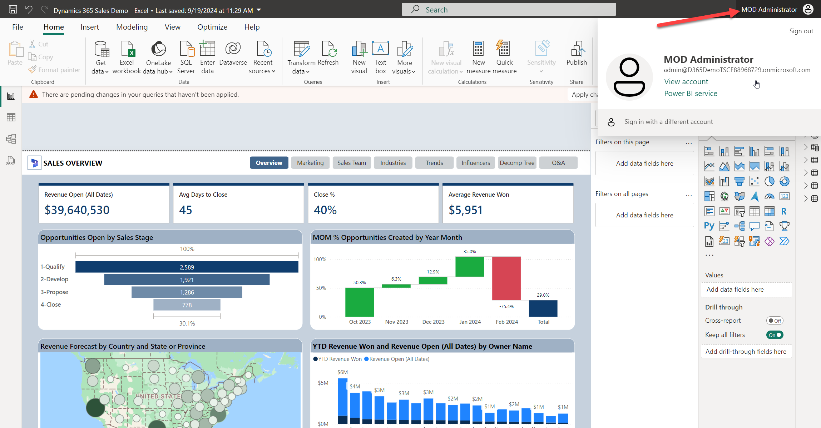
5. To update the data source, select “Transform Data 🡪 Edit Parameters”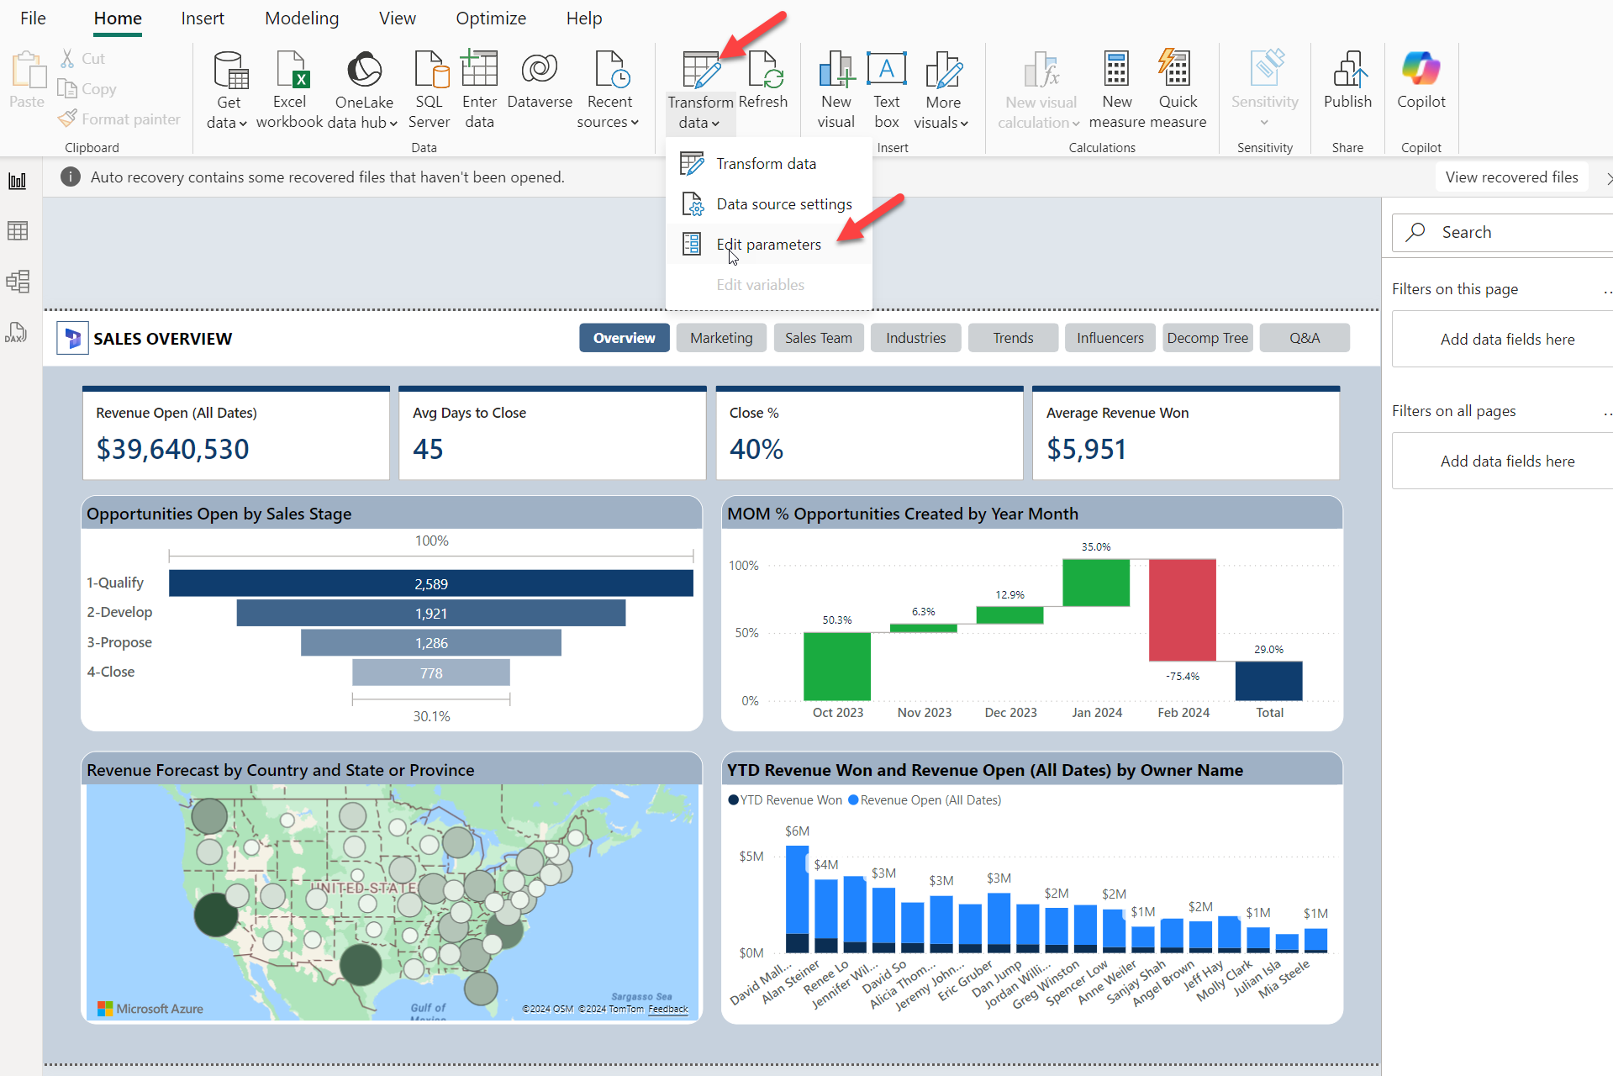
6. Paste in excel path for source data that you gathered in Section 2 step 4 above (be sure to remove the ?web=1)  
   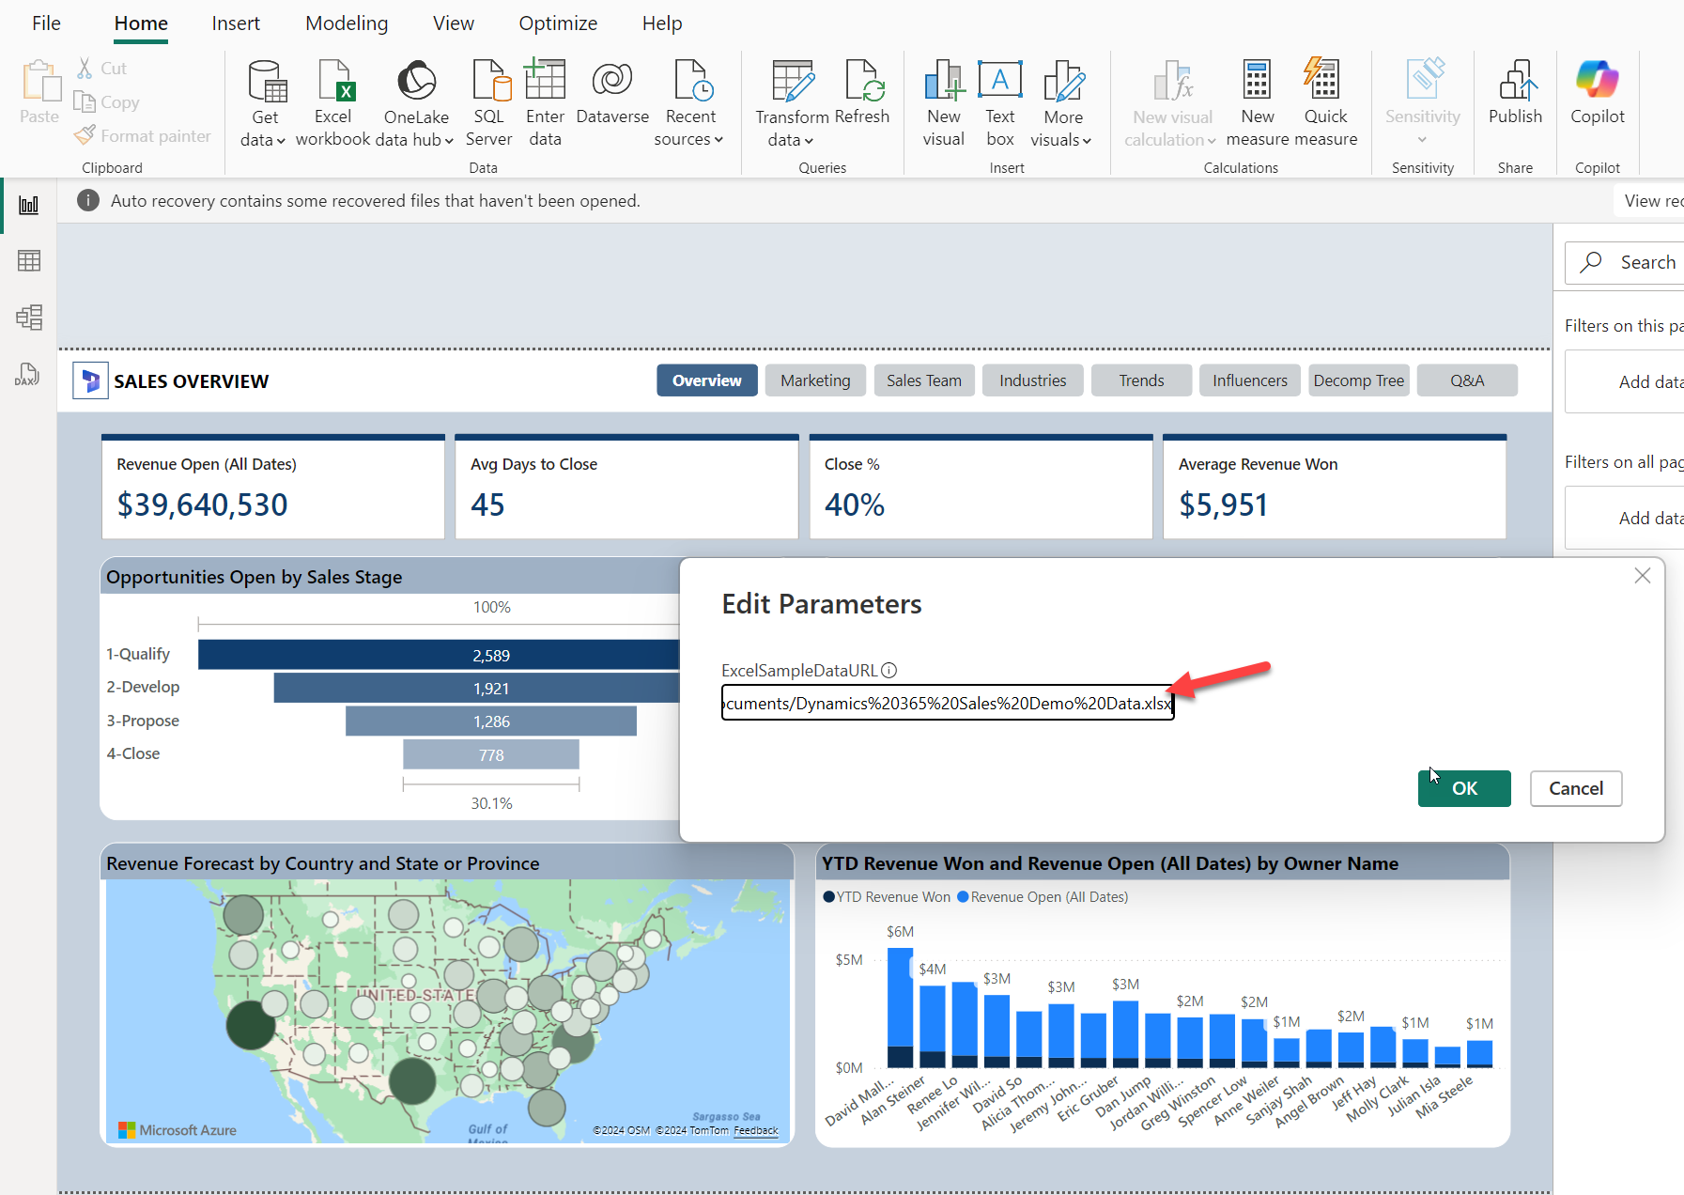
7. After Changing the source, you will see a banner pop on the top of the screen to Apply Changes. Select Apply Changes.   
   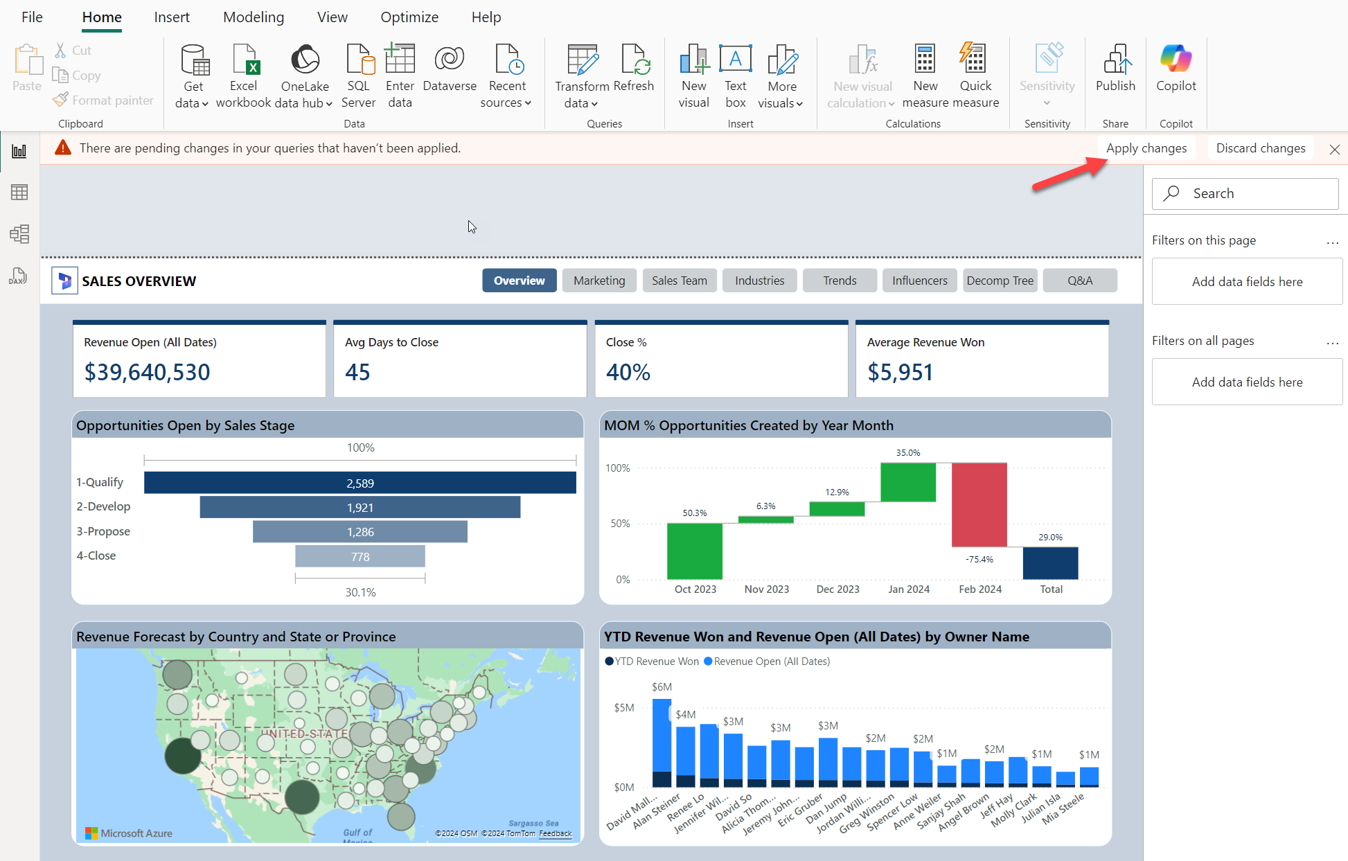  
     
   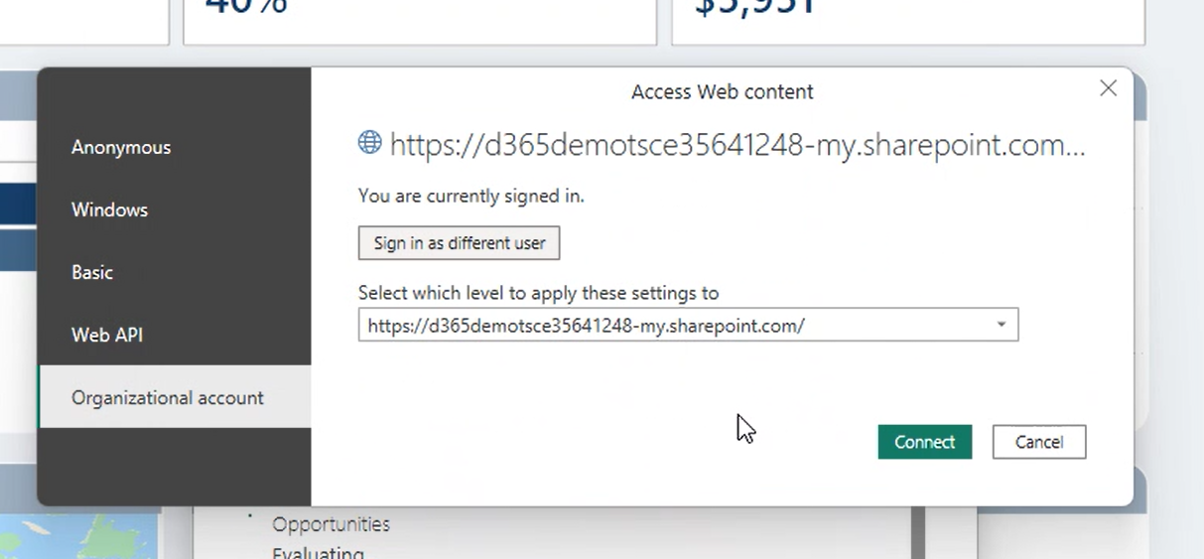
8. Publish the Power BI report to your new Workspace in Power BI Online (Select File 🡪 Publish 🡪 Publish to Power BI)  
   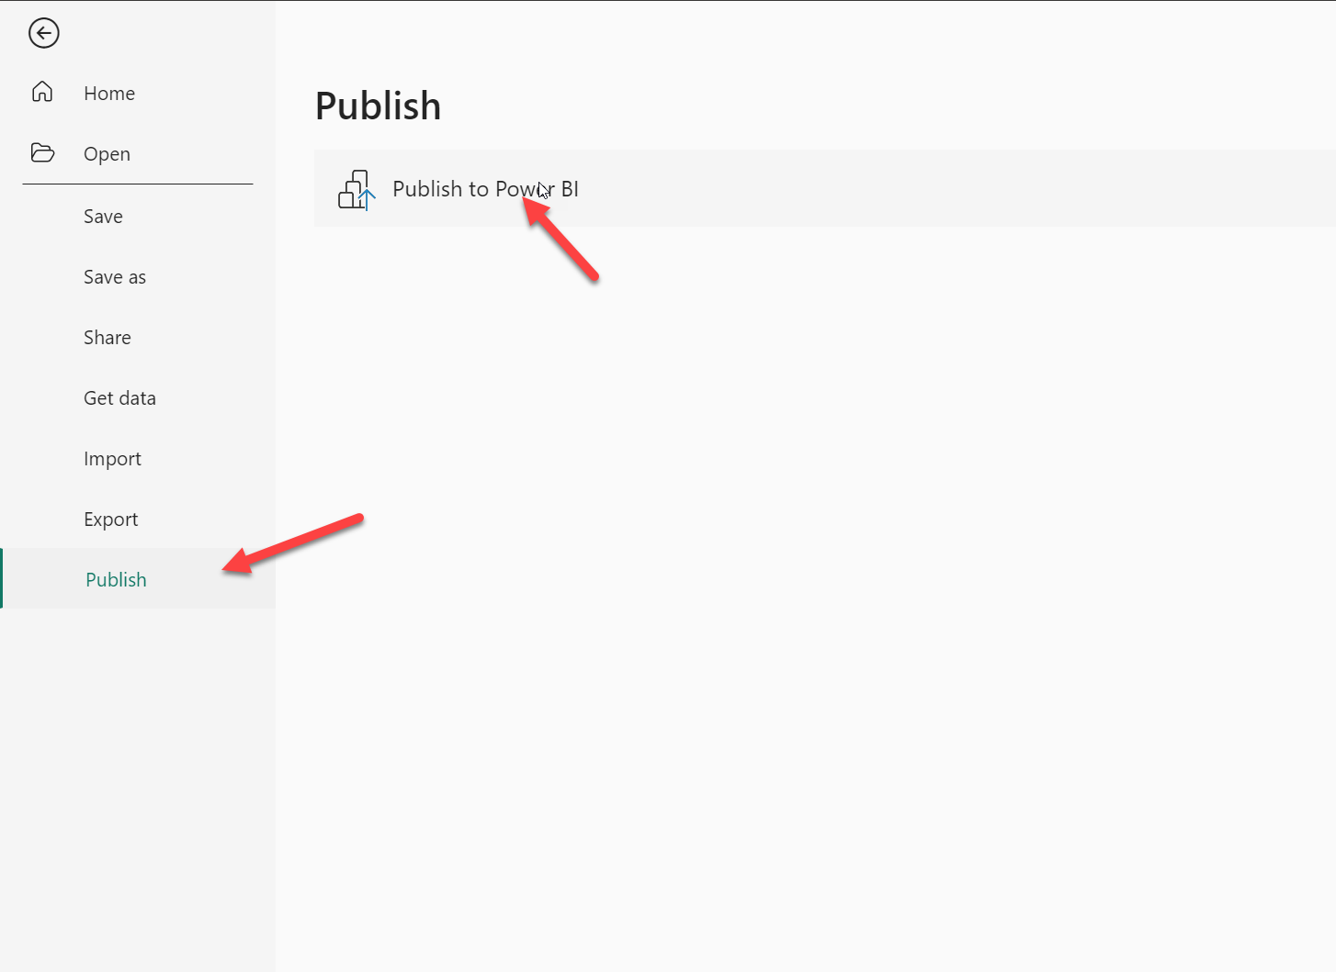
9. Select Power BI workspace that was created in Section 3 Step 3 above.   
   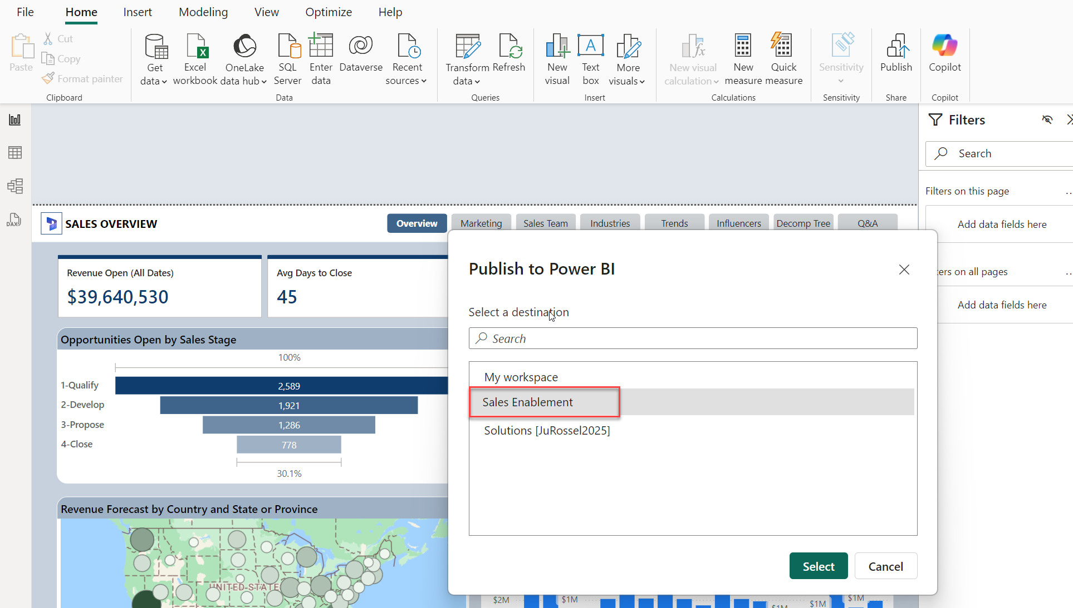

# Embed Power BI Dashboard in D365 Dashboard list.

1. Open PowerApps and select a solution that you want to use to make these changes. **Alternatively**, you could create a solution for this dashboard modification. <https://make.powerapps.com/> (Ensure that you are working in the correct environment where you want to make this modification)  
   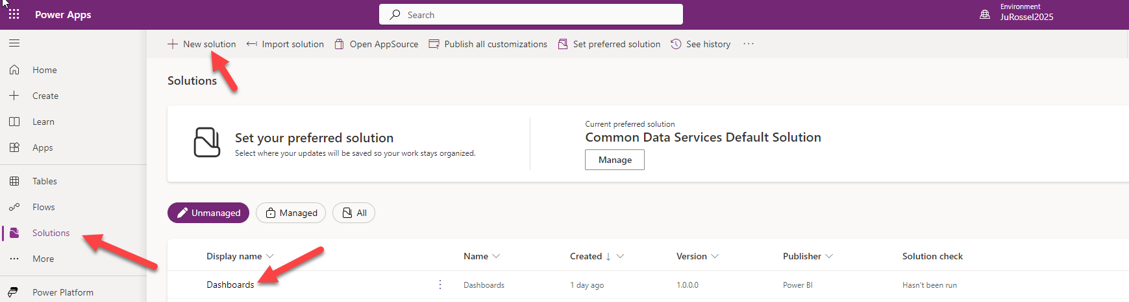
2. Once within a solution, select New 🡪 Dashboard 🡪 Power BI Embedded  
   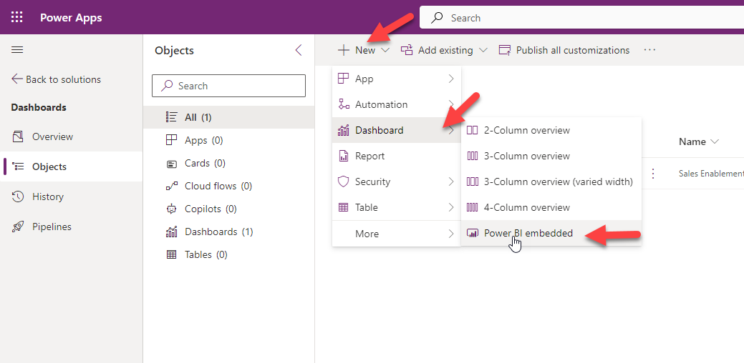
3. Name your D365 Dashboard 🡪 Select the Workspace where you deployed it in above step 🡪 select the Power BI report  
   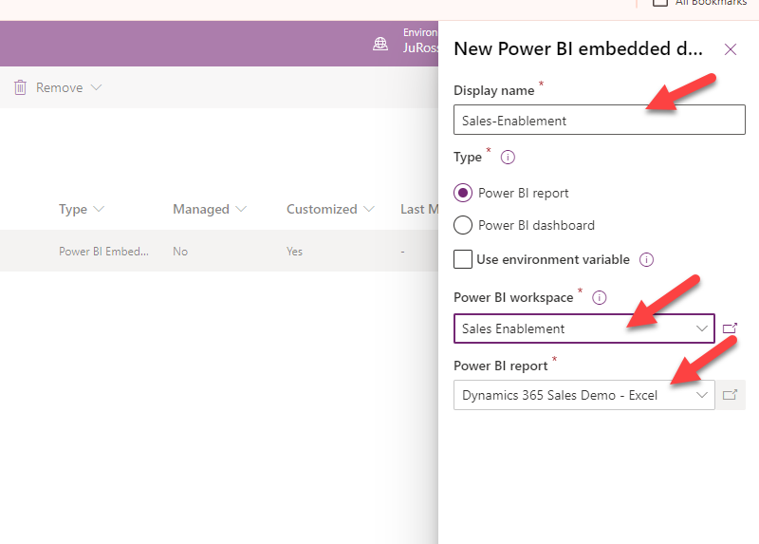

# Enable the New Power BI Report and Publish all Changes

1. GO to the PowerApps Home Page and select the D365 App where you want to publish this Dashboard (Typically Sales Hub or Customer Insights -Journeys)  
   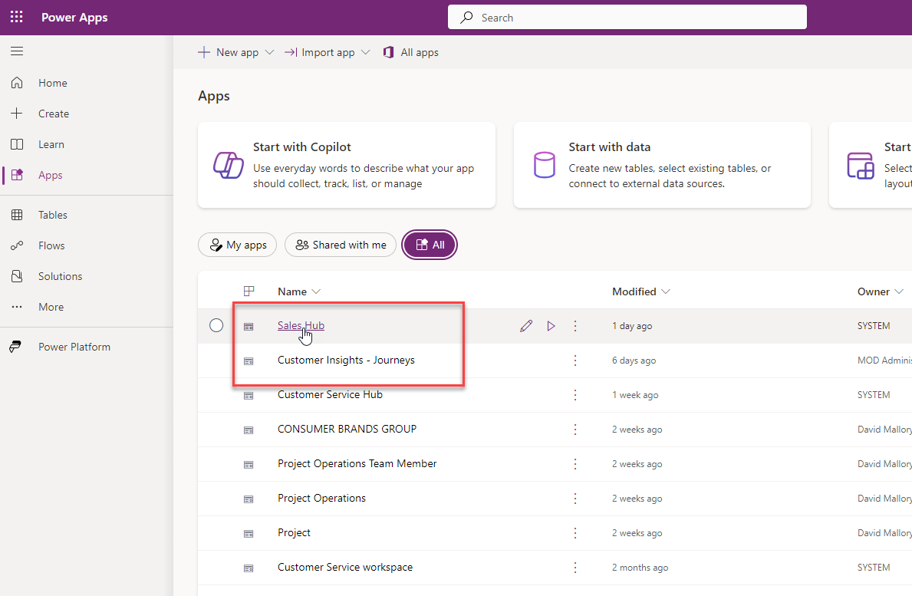
2. Select the Ellipsis and Switch to Classic  
   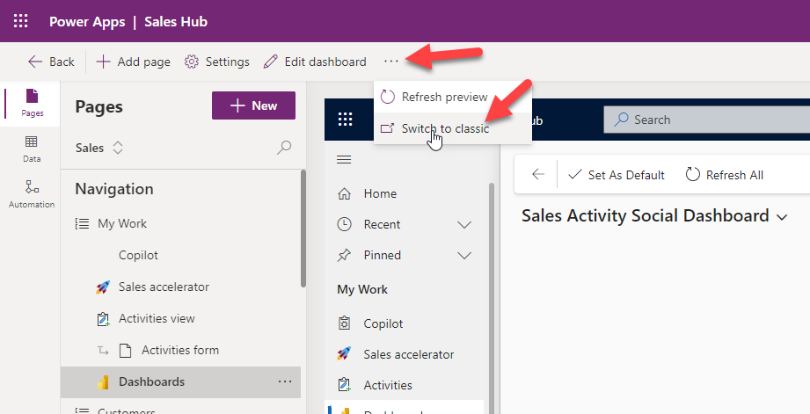
3. From The App Designer Select Dashboards 🡪 Scroll to the bottom on the right hand side and select the dashboard just created. 🡪 Save and Close  
   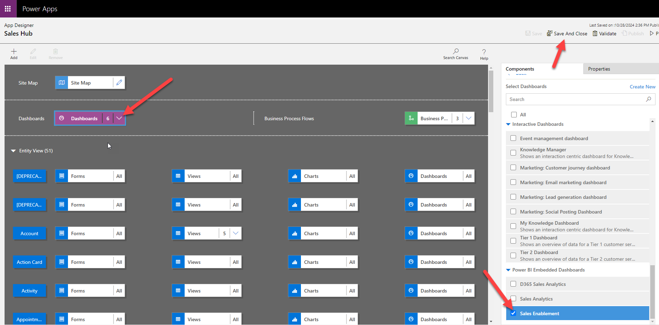
4. Publish your Changes  
   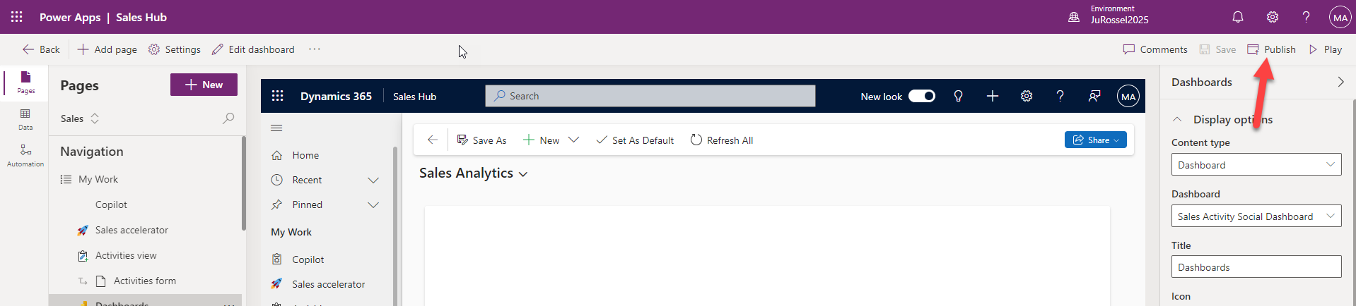
5. Validate the Dashboard now shows in the dashboard dropdown.   
   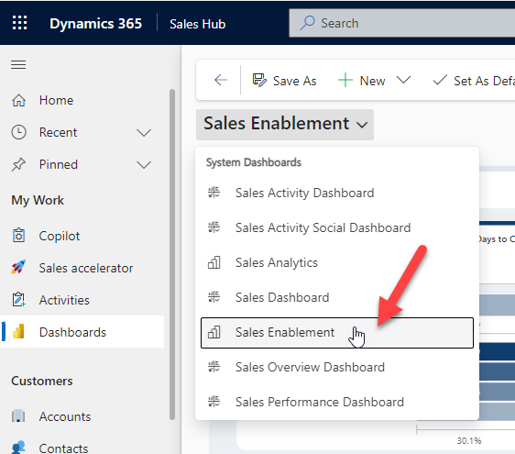

# Hints

1. No more than an hour before a demo it’s a good idea to load the report once and click through everything just to warm up the cache.
2. If the report is open in a tab and sits idle for a period, it may time out – just click the browser’s page refresh button. The ‘Refresh All’ button inside CRM does nothing to reload the report.
3. *Temporary Requirement for enabling Azure Maps*

Power BI is changing to enable Azure Maps by default, but until then, for any new environment you may need to enable the Azure Maps toggle switch. This is a tenant-wide setting, so you only need to set it once per organization.

* 1. In PowerBI.com, click the “Settings” gear icon  
     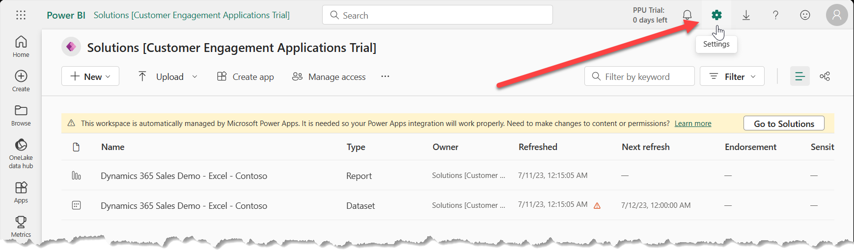
  2. Under “Governance and Insights” Select the “Admin portal”
  3. Scroll down the list of Tenant settings until you find the “Use Azure Maps visual” setting (in the “Integration settings” section.)
  4. Set that value to “Enabled” and click “Apply”  
     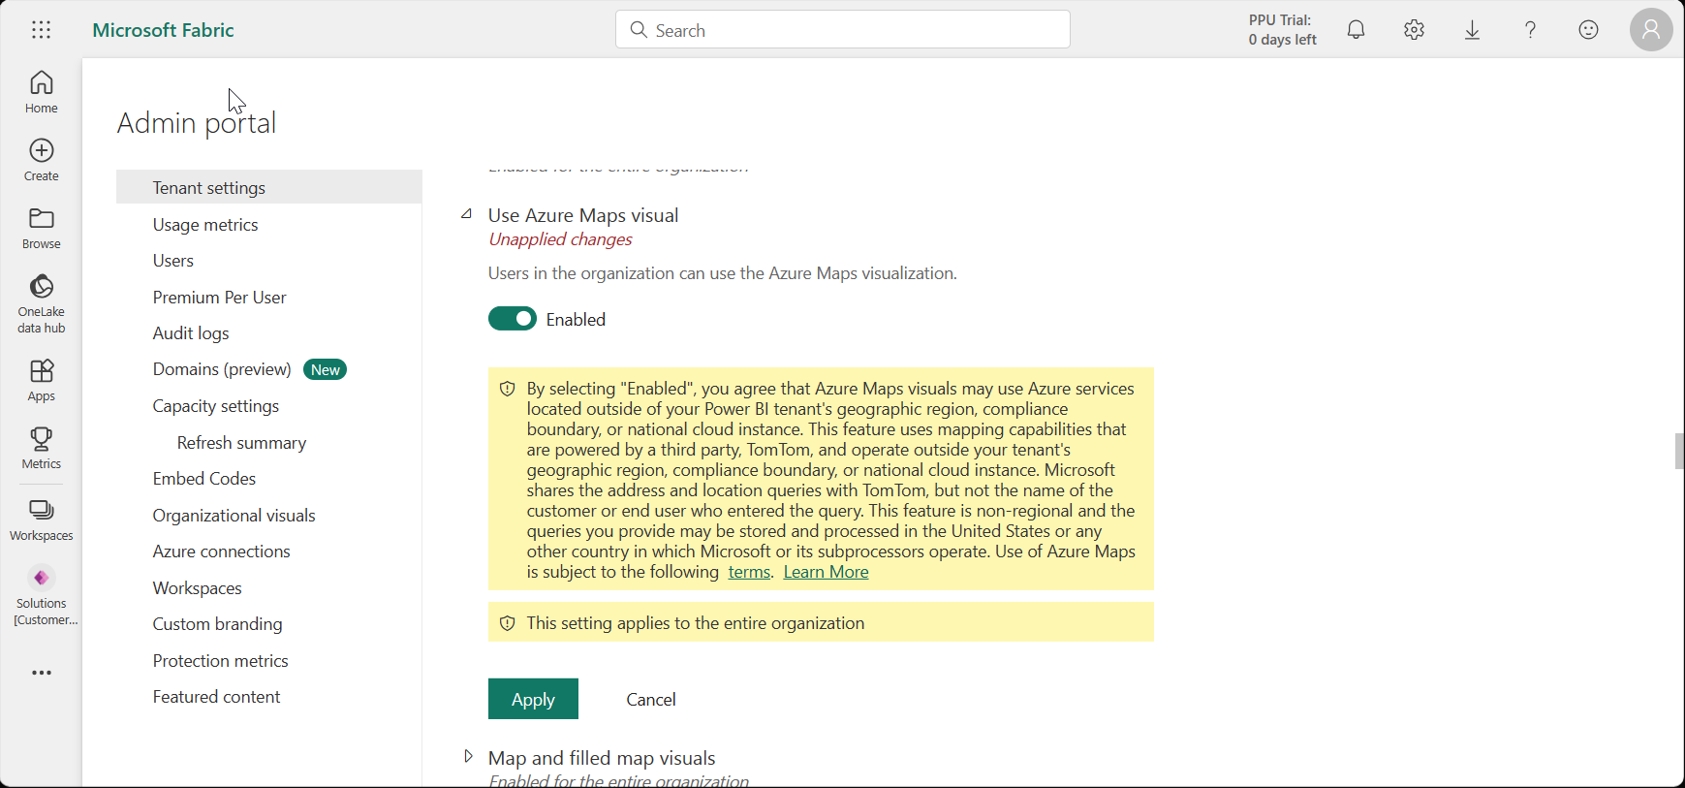
  5. It may take a few minutes for the setting to propagate to your report, but just refresh the page once or twice until the map on the first page displays correctly.